Implement Conversation Completeness Metric

Objective
Add a new RAG evaluation metric named "Conversation Completeness" using the same architecture already used by the existing metrics.
Maintain UI consistency with all existing evaluation metrics.
Do not redesign existing components.

Metric Name
Conversation Completeness

Metric Purpose
Conversation Completeness evaluates whether the generated answer completely addresses the user's query by covering all relevant aspects without omitting important information, any gaps or partial resposnses.

Teaching Mode

Overview
Explain:
- What conversation completeness means in AI systems
- Why complete responses improve user experience
- Why incomplete answers reduce usefulness
- Why enterprises evaluate response completeness

Advantages
- Ensures user queries are fully answered
- Improves response quality
- Reduces follow-up questions
- Enhances customer satisfaction

Limitations
- Completeness may depend on available context
- User intent may sometimes be ambiguous
- Completeness can be subjective

- Overly detailed answers may overwhelm users
- Longer responses are not always more complete
- Different users may expect different levels of detail

Industry Usage
- Customer support assistants
- Enterprise knowledge assistants
- Banking virtual assistants
- Healthcare chatbots
- Educational tutoring systems

Real World Applications
- FAQ assistants
- Technical support copilots
- Insurance claim assistants
- Banking copilots explaining loan processes
- HR helpdesk bots
- IT service desk assistants

Best Practices
- Cover all aspects of the query
- Include all relevant information available in the context
- Avoid leaving important points unanswered
- Provide structured, clear responses
- Avoid unnecessary repetition
- Validate responses against the original query

Common Mistakes
- Answering only part of the question
- Providing vague or partial answers
- Over-focusing on one aspect while missing others
- Assuming context without verifying
- Ignoring follow-up instructions within the query

Good Example
Question:
How can I reset my password and update my registered email address?
Generated Answer:
To reset your password, select Forgot Password on the login page and follow the verification steps. To update your registered email address, log in to your account, navigate to Profile Settings, choose Email, enter the new email address, verify it using the OTP, and save the changes.
Result:
High Conversation Completeness

Bad Example
Question:
How can I reset my password and update my registered email address?
Generated Answer:
Click Forgot Password on the login page to reset your password.
Result:
Low Conversation Completeness

Score Interpretation
Score | Interpretation
0.90 – 1.00 | Highly Complete
0.75 – 0.89 | Mostly Complete
0.50 – 0.74 | Partially Complete
Below 0.50 | Incomplete Response

Sample Library
Create Good and Bad examples for:
- Banking
- Healthcare
- Customer Support
- Education
- E-commerce

Q&A Prep
Add beginner-friendly questions:
- What is Conversation Completeness?
- Why is conversation completeness important?
- Can a response be correct but incomplete?
- How do enterprises evaluate conversation completeness?

UI Requirements
Reuse:
- Existing metric selector
- Existing teaching mode
- Existing sample library
- Existing evaluation workflow
- Existing result cards
Ensure the Conversation Completeness metric feels identical to the existing metrics already implemented.
http://localhost:5174/
CONVERSATION COMPLETENESS metric is added to the library with teaching mode , Advantages, Limitations and Usage
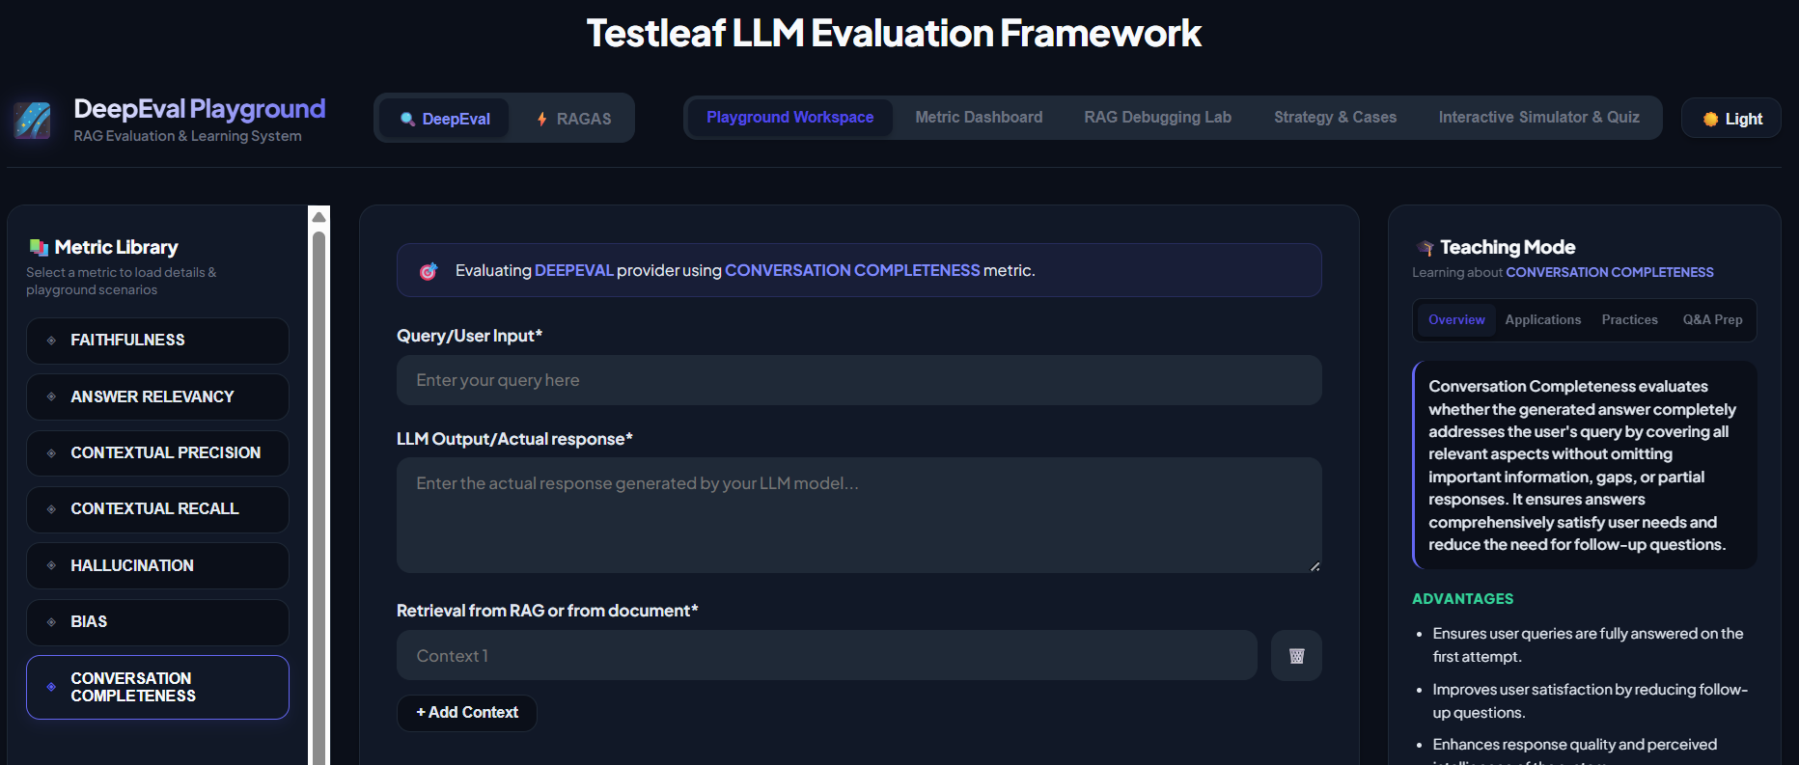
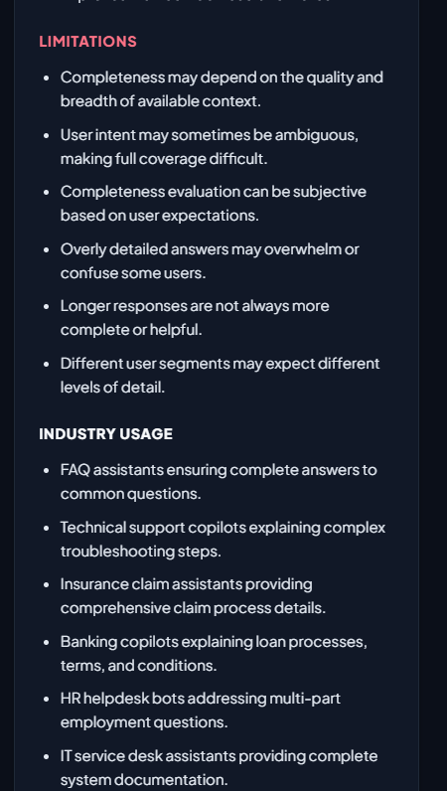
Applications
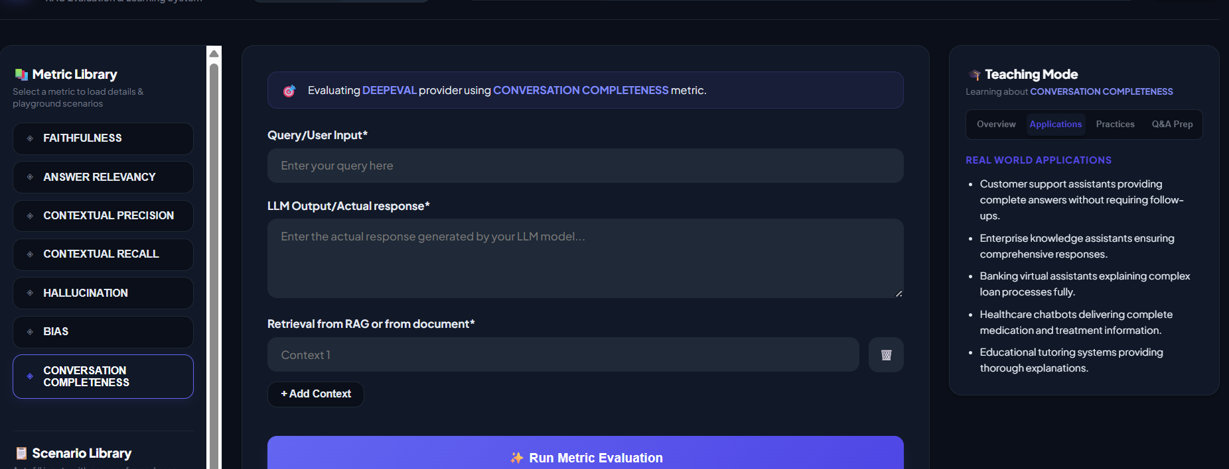
Best Practices
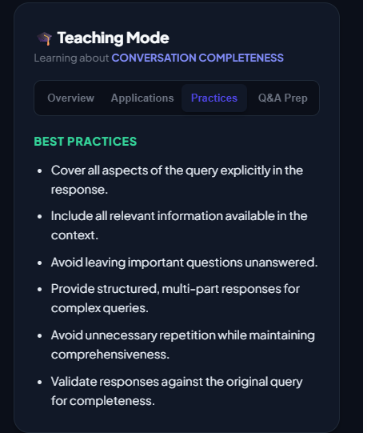
Q&A Prep
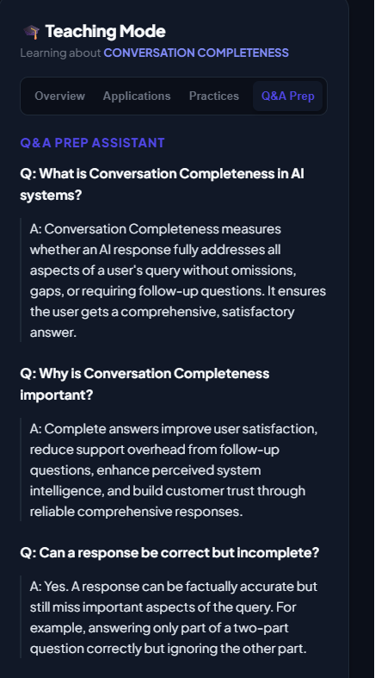

Scenario Library:
